**Transformations in PySpark RDDs**

**The .map() Transformation**

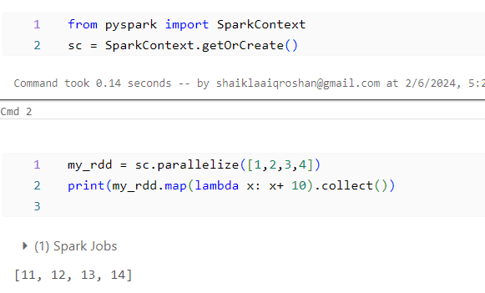

**The .filter() Transformation**

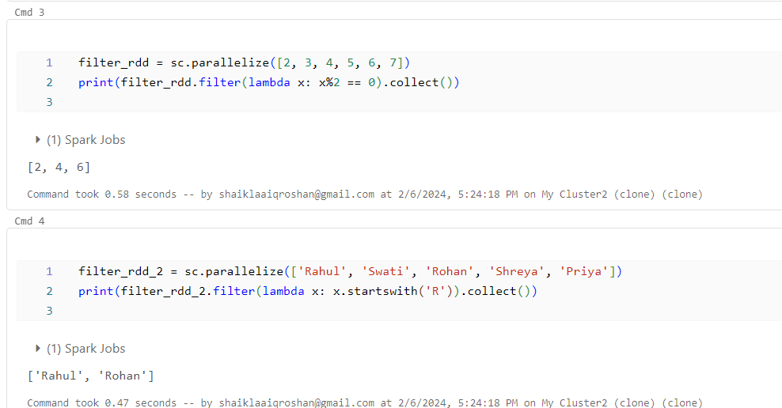

**The .union() Transformation**

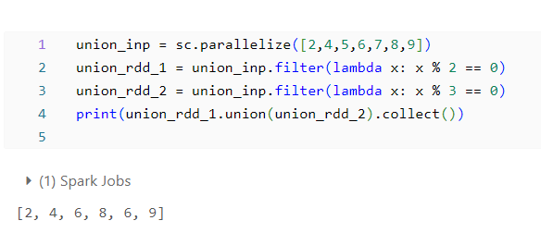

**The .flatMap() Transformation**

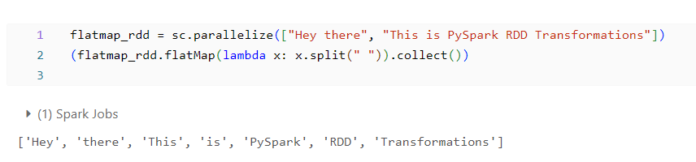

**PySpark Pair RDD Operations**

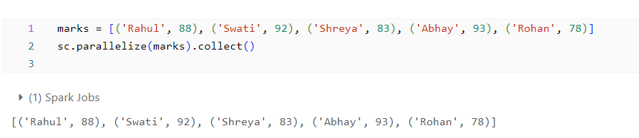

**Transformations in Pair RDDs**

**The .reduceByKey() Transformation**

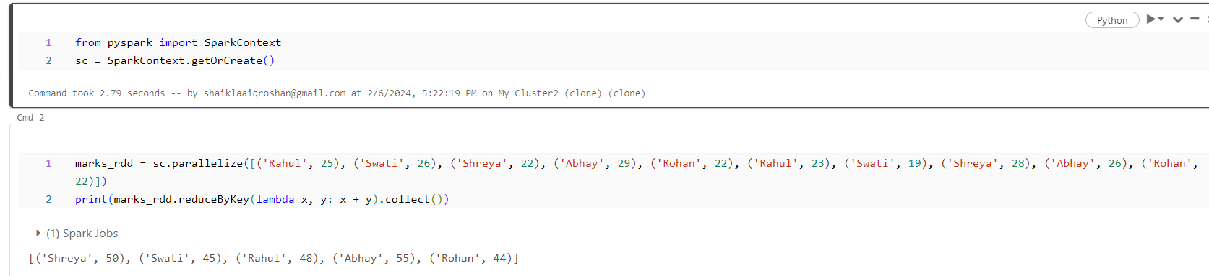

**The .sortByKey() Transformation**

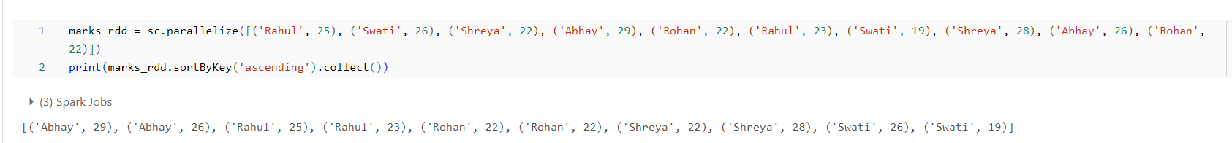

**The .groupByKey() Transformation**

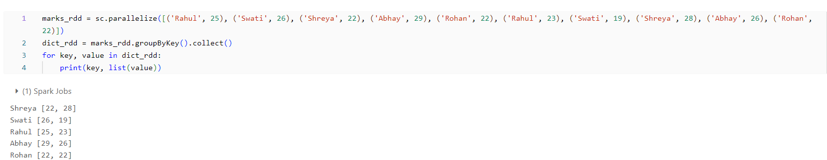

**Actions in Pair RDDs**

**The countByKey() Action**

